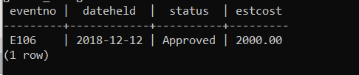

SELECT eventrequest.eventno, dateheld, status, estcost

FROM eventrequest, facility, eventplan, employee

WHERE eventrequest.facno = facility.facno

AND eventrequest.eventno = eventplan.eventno

AND eventplan.empno = employee.empno

AND facname = 'Basketball arena'

AND empname = 'Mary Manager'

AND dateheld BETWEEN '2018-10-01' AND '2018-12-31';